Expedited Service Terms

Thank you for requesting expedited service. We offer two levels of expedited service: 15-20 working days and 30-40 working days. Expedited service is available at the discretion of QCS based on operational capacity including but not limited to inspector availability, certification review workload, and administrative capabilities. It is necessary that we work together to meet these timelines. Once a new client requests expedited service, our Client Care Specialist will verify with the appropriate QCS teams if we can accommodate the request; the Client Care Specialist will reach out to the client with approval or denial of expedited service.

QCS is committed to meeting all expedited deadlines according to the responsibilities laid out in this document. With QCS’s approval of expedited service, you agree to respond promptly to all QCS communications regarding your organic system plan. Delays due to incomplete or incorrect applications, or failure to respond to QCS communication are the responsibility of the client requesting expedited service.

QCS’s review and inspection timeline for expedited service does not include time that we are waiting for client responses or responses from other parties, including but not limited to certification bodies, input manufacturers, and/or suppliers.
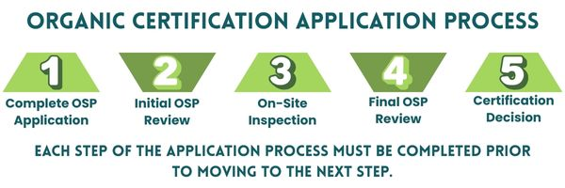
Fees for Expedited Service: There is an additional certification and inspection fee for expedited service. When you submit your application, please include both the standard certification fee and the expedited certification fee. We cannot process expedited applications until all certification fees are received. Please see our fee schedule for a full explanation of our fees, including the additional costs for inspection. All fees for expedited service are non-refundable.

What do we mean by working day? Timeframes for completion of expedited services are based on business working days of the typical 5-day workweek during which QCS can complete services, excluding public holidays. These timeframes do not include any days in which QCS is waiting for your response to requested information or corrective actions if noncompliances are identified.
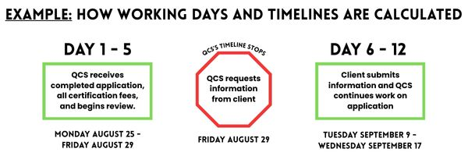

In the example above, we begin our initial review of the application on Monday, August 27th and send a request for information to the client on Friday, August 29th. Our calculation of the expedited timeline stops upon sending the request to the client. We do not include the 5 working days (excluding Monday September 1 as a holiday) that we were waiting for a response from the client. We restart our timeline calculation once we receive the information from the client.

Application Processing: We begin reviewing your application upon receipt of the completed Organic System Plan application and certification fee payment. A reviewer may request additional information as needed to verify the plan is complete and compliant. To assist us with meeting your requested timeline:

- Prior to sending, ensure your application is complete. Incomplete applications can cause significant delays in review, inspection, and certification decisions.
- Please respond to communications regarding your application in a timely manner.
- Make sure you’ve added us to your email’s safe sender list; our team primarily reaches out through email.

Inspection Scheduling: A QCS inspector will reach out to you to schedule your inspection. Prior to your inspection, please make sure you have your full OSP (Organic System Plan) and records demonstrating its implementation ready for the inspector to review. You can find our checklist “Are You Ready for Inspection?” in this packet. Think ahead about your inspection when preparing your application for submission!

Inspector availability for a rush inspection may be a very narrow window. If you cannot make the inspection timing work with the assigned inspector’s schedule and availability, this may impact the expedited timeline and lead to higher inspection fees. QCS is responsible for securing an inspector with availability during the expedited timeline; clients are responsible for being available for inspection during the inspector’s availability. Please see below section on rescheduled/cancelled expedited inspection.
Fees for rescheduled/cancelled expedited inspections: When working on an expedited timeline, QCS needs to secure the time of one of our qualified inspectors on very short notice. They must block off adequate windows of time for your inspection, which may be on hold for other assignments, and they often incur additional expenses making necessary travel arrangements on short notice. Much of the inspection planning work, by necessity, will occur concurrently with your initial review, which must be completed before an inspection can take place.

To ensure inspectors are compensated for all expenses, lost revenue, and lost opportunity costs when delays or cancellation of expedited inspections occur, there will be an additional $600 + expenses fee charged for all cancelled/delayed inspections of expedited applications, provided the situation meets these conditions:

- Application and expedited fees have been submitted to QCS;
- QCS assigns an inspector;
- The inspector and client have settled on an inspection date, and;
- The inspection is delayed due to:
  - an initial review that’s been extended by prolonged requests for information required to correct the submission of an incomplete application;
  - delayed client responses to requests for information;
  - cancellation due to personnel availability;
  - unforeseen plant/farm closures; and/or
  - other delays attributable to the client.

Final Review: After the inspection, a certification reviewer will review the inspection report and any updates submitted with it; they may reach out for missing information or to address findings before making a certification decision.

Extenuating circumstances: In instances where delays occur that are outside the responsibility of either the client or QCS (for example, waiting for information from suppliers, certification bodies and/or input manufacturers), QCS is not responsible for the delays in certification decisions. By taking on an expedited application, QCS makes a good faith effort to collect the necessary compliance information from third parties within the expedited timeline. Clients must also be engaged in the process of obtaining information from third parties as it pertains to the compliance verification of their application.

QCS does not guarantee a positive certification decision, and the client understands that paying for expedited service does not guarantee certification. The applicant is responsible for payment of all invoices and fees associated with expedited service regardless of certification decision.

What to submit: Complete OSP with all attachments, fee form, all fees. Send applications to apply@qcsinfo.org and work with our Client Services Team to ensure that fees are paid and timelines can be met.

