How to Download an Organic Certificate from the Organic Integrity Database (OID)

Please note: All organic certificates are now issued directly from the Organic Integrity Database. Clients are responsible for downloading a copy of their current organic certificate. QCS will send clients their Product Verification Forms directly.

Instructions

Go to the OID homepage url: https://organic.ams.usda.gov/Integrity/

Type in the operation name into the search bar under the Operation column and press “enter” on your keyboard to start the search.

Click on the operation name that appears to open the OID profile.
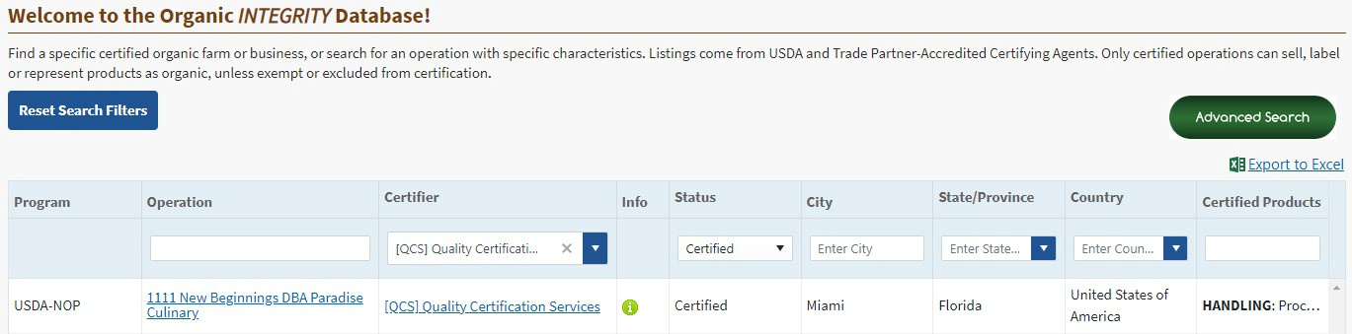



On the OID profile page, you can view all publicly available certification details.

To download a digital copy of the operation’s certification, in the top right corner select Export to PDF for the Operation Profile or Print Certificate for the Organic Certificate.
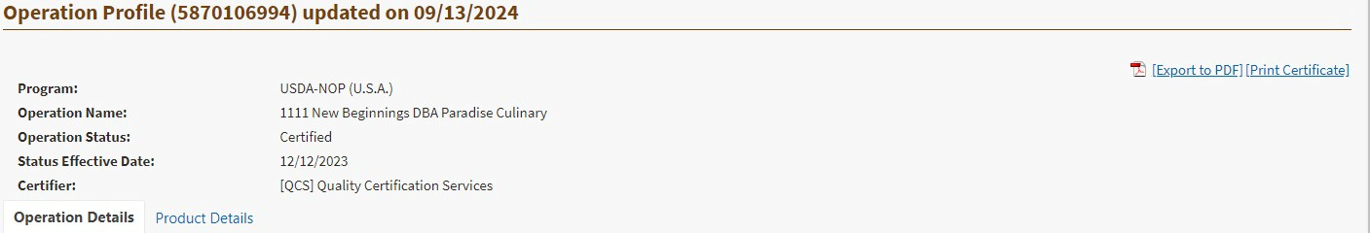


Open the download to view, print, or save as needed.

If you have any questions about getting your organic certificate, please call us at 352-377-0133 or contact your Certification Project Coordinator.

